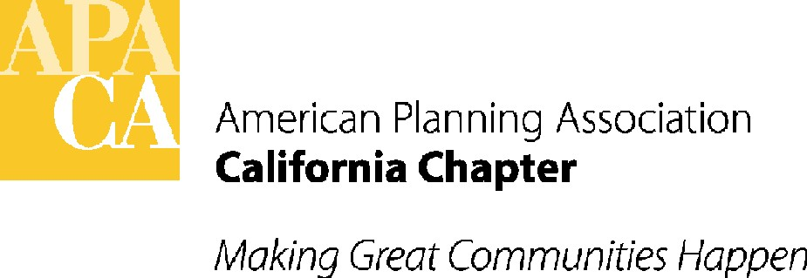 Agenda Item A-2

ACTION MINUTES

APA California Board Meeting

June 15, 2012

Via Conference Call

ATTENDEES:
EXECUTIVE BOARD
President Kevin Keller, AICP
VP, Policy & Legislation David Snow, AICP
VP, Public Information Hing Wong, FAICP
VP, Professional Development Juan Borrelli, AICP
VP, Administration Virginia Viado
VP, Conferences Janna Minsk, AICP
President Elect Brooke Peterson
Student Representative Cindy Ma
CPF President Linda Tatum, AICP
Planning Commission Representative Mark Yeber

SECTION DIRECTORS
Central Ralph Kachadourian
Northern Hanson Hom, AICP
Orange County Jennifer Lilley, AICP
Sacramento Valley Julia Lave Johnston
San Diego Daniel Wery, AICP
Central Coast Dave Ward, AICP
Inland Empire Liesa Lukes, RLA
Los Angeles Marissa Aho

STAFF
Executive Director/Lobbyist Sande George
Director of Administration Tom Stefan
Lobbyist Lauren Silva

ACTION ITEMS FROM BOARD MEETING

- CALL TO ORDER
President Kevin Keller called the meeting to order at 9 am.
- APPROVAL OF CONSENT ITEMS
- Approval of Agenda, Membership Report and Financial Reports –ACTION: The Board moved, seconded and passed to approve the Consent Items. Unanimous vote.
- Approval of June 2012 Minutes – ACTION: The Board moved, seconded and passed to approve the January 2012 Minutes from the Board Meeting. Unanimous vote.
- ACTION ITEMS

Board Committee Task/Action Item Review: Kevin Keller suggested that it would be helpful to put together an ongoing list of active committees that could be discussed at Board meetings that would include the committee’s task, action items and targeted dates for completion to ensure that Board actions are completed. Dan Wery suggested that in addition to the more official committee list, that the action minutes from previous Board meetings be reviewed during the following Board meeting, asking those responsible for completion of the action item to provide the Board with an update and status. Kevin will work with Lauren to develop a list/process for review of action items on future Board and Executive Board agendas.

APA National Meeting: Kevin Keller requested that an item be added to the fall Board meeting agenda to discuss the lending library transition date from the Chapter’s CD lending system to National’s new downloaded system.

Budget Committee Report and Recommendations – Action: After extensive discussion, the Board moved, seconded and passed to approve the recommendation of the Budget Subcommittee to adopt a flat $20 dues increase effective January 2013. According to National’s schedule, members would see the increase in their next dues invoice from National at the end of 2012. Kevin and Virginia will work with the Budget Committee to develop a report to members to explain the dues increase, why it was chosen, what the Board has already done to reduce expenses, and the need to maintain and replace reserves. The report will specifically highlight the continued and increased services that the dues increase will provide as a value to members. The complete draft report will be distributed to Board members at the conference meeting in October, which will be approximately two months before the increase takes effect, unless the report can be completed prior to the Board meeting. The final Annual Report will be distributed to members by e-blast. The motion passed 8-6 with the following vote:
Yes: Virginia Viado, Janna Minsk, Dave Snow, Brooke Peterson, Mark Yerber, Cindy Ma, Marissa Aho, Kevin Keller

No: Jennifer Lilley, Hanson Hom, Dave Ward, Ralph Kachadourian,
Julia Lave Johnston, Dan Wery

Section Direct Link to Legislative Information/Capitol Track: The Sections requested that Stefan/George look into the cost and feasibility of providing a direct link to legislative information on each Section’s website similar to the link on the Chapter website homepage as another way of keeping members informed on the Chapter’s legislative activities. Sande George reported that currently, the link on the Chapter website is provided through the Stefan/George Capitol Track account, but that it would be possible to add a hot link to each Section’s website through her account. The cost would be $5 per month per link. For 9 links (for the Chapter and the 8 sections) the cost would be $45 per month/$540 per year. The Board, after supporting the hot link proposal, asked Dan Wery and Sande George to come back to the Board at the conference Board meeting recommending how to pay for the annual fee between the Sections and Chapter, and whether or not the legislative link should be available to members only.

Marketing and Membership Update: Virginia Viado asked that feedback on the Marketing and Membership Plan be given to her or Derek Hull. Virginia will host a call with Sections and other interested Board members in the next few weeks to discuss.

Conference 2014 Hotel Approval - Action: The Board moved, seconded and passed to approve the Disneyland Hotel as the official hotel for the 2014 conference. Unanimous vote.

Contracts Committee Update: Brooke Peterson asked the Board to review the Contracts Committee Report recommendations and email her any changes or additions, particularly any changes related to the contract review cycle and the evaluation criteria. The Board asked that the criteria be ranked from 1-5 to give the Board an idea where contractors are excelling and where they may need improvement, and that clarifying language be added that the contracts will be reviewed annually during the budget process. Brooke will also amend the process to require an annual review of the Scope of Services for each contractor to ensure the services reflect what the Board needs.

Bylaws Update: The Board reviewed the updated Bylaws that Brooke Peterson provided. Brooke will correct the Table of Contents and the AICP Coordinator title, and will work with Mark Yeber to update the Planning Commissioner section. VP’s were also asked to send Brooke any updates. Brooke will provide the final Bylaws to the Board at the conference Board meeting.

Student Survey: Cindy Ma asked Section Directors to update their Student Representative information on their website rosters so students know who to contact at the local level.

Next Board Meeting: The next Board meeting will be at the conference in Rancho Las Palmas, Rancho Mirage Hotel, Sunday, October 21 from 9:30 am to 4:30 pm.

V. ADJOURNMENT
The meeting was adjourned at 1:00 pm.

